**Covid UseCase Using Databricks**

**Using Pyspark:**

**Display the files in the Databricks:**

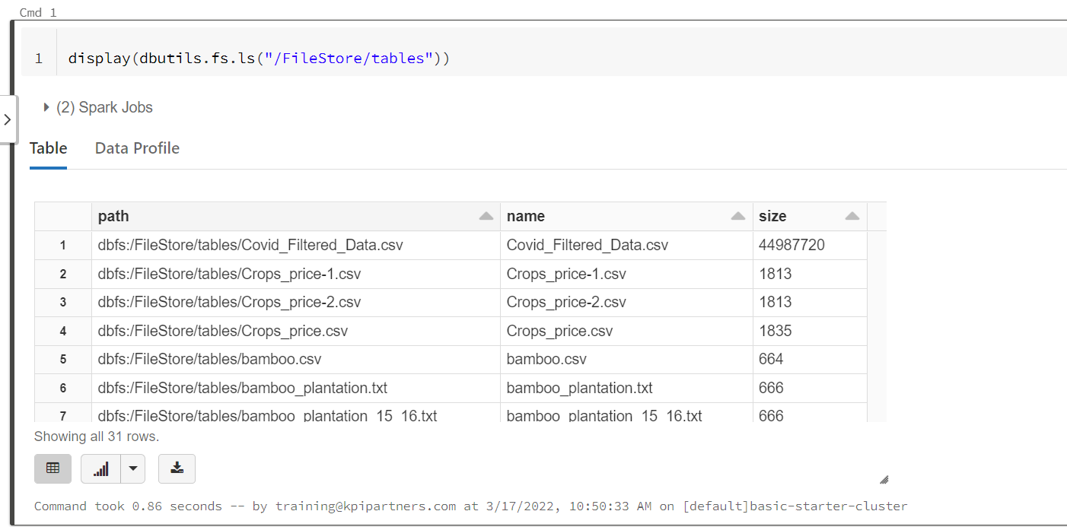

**Reading the file in Databricks:**

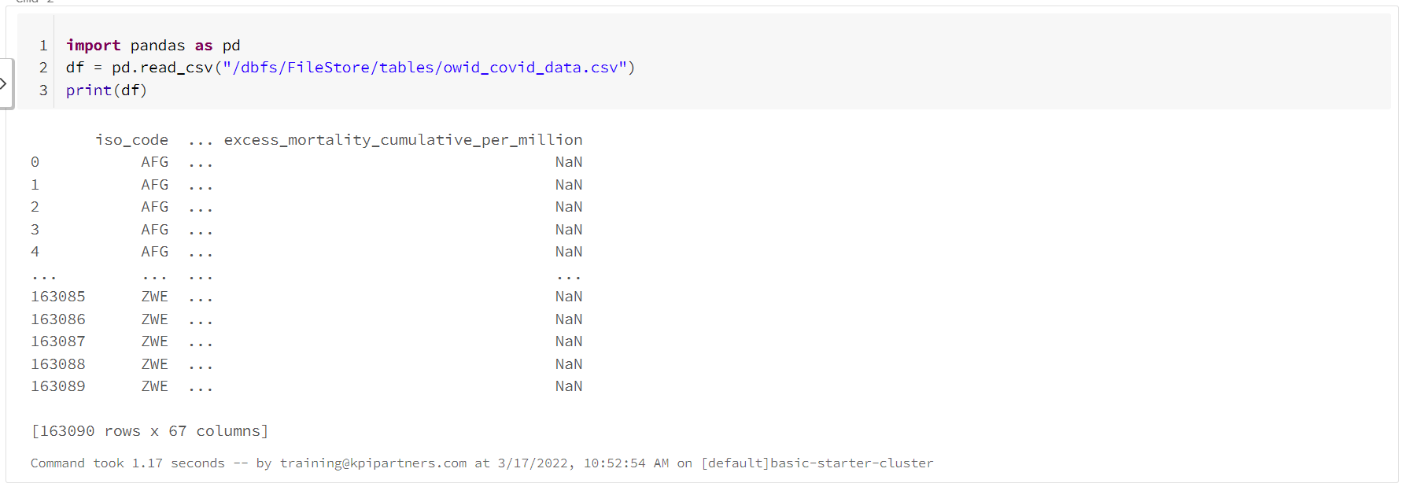

1. **Remove the records where the continent column having blanks**

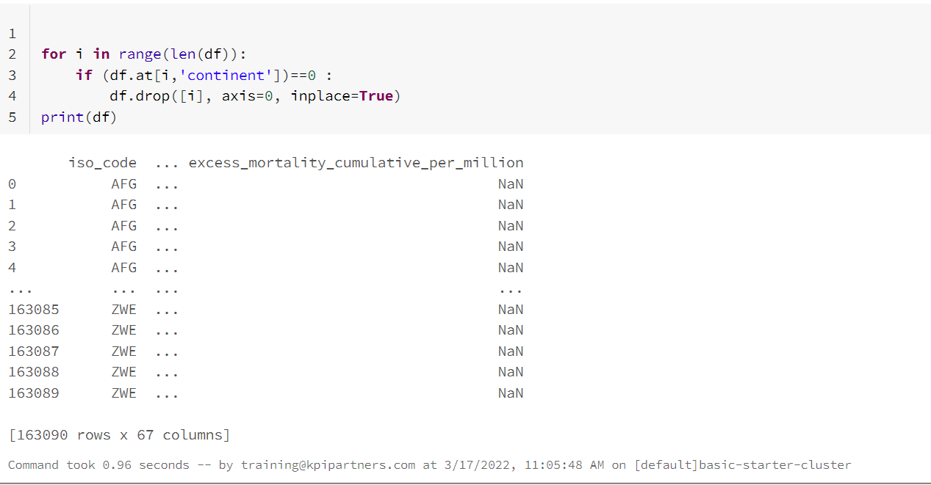

**2. Replace all the NEGATIVE and NULL valued records with 0**



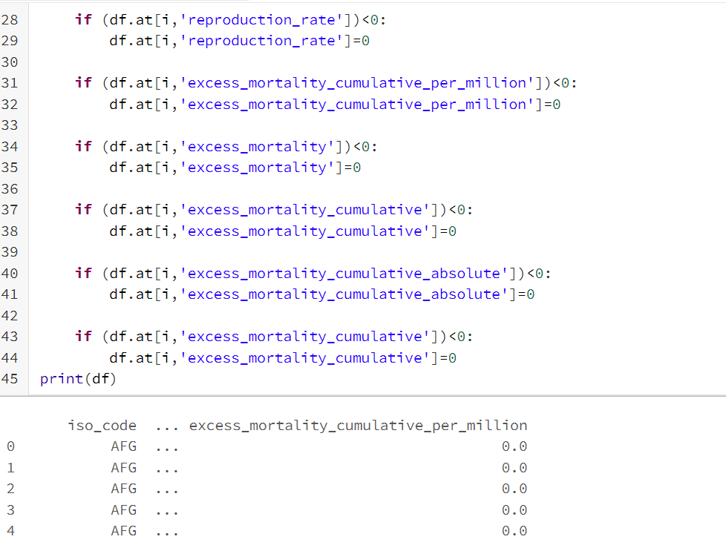

**Reading the file for querying:**

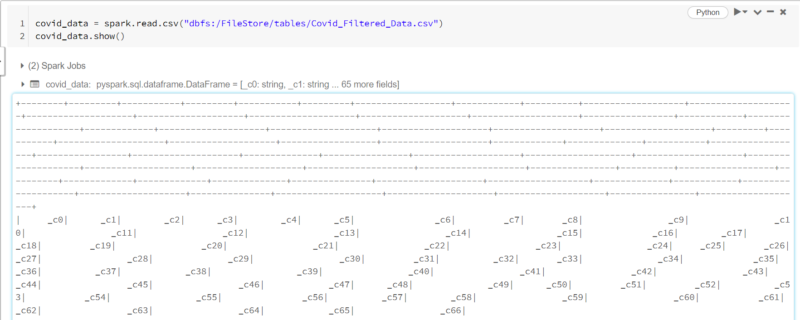

**Creating Temporary View:**



**3. Positivity rate where the stringency index is maximum.**

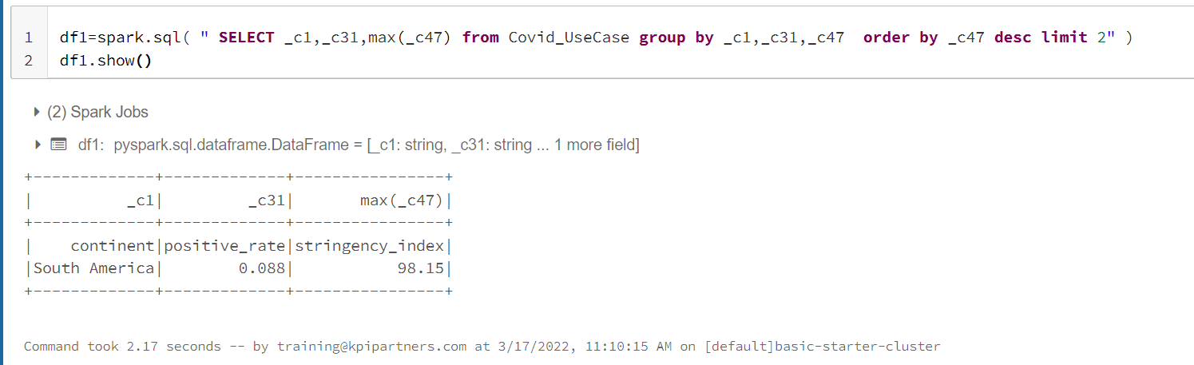

**4. Which continent and location having max of deaths and male_smokers**

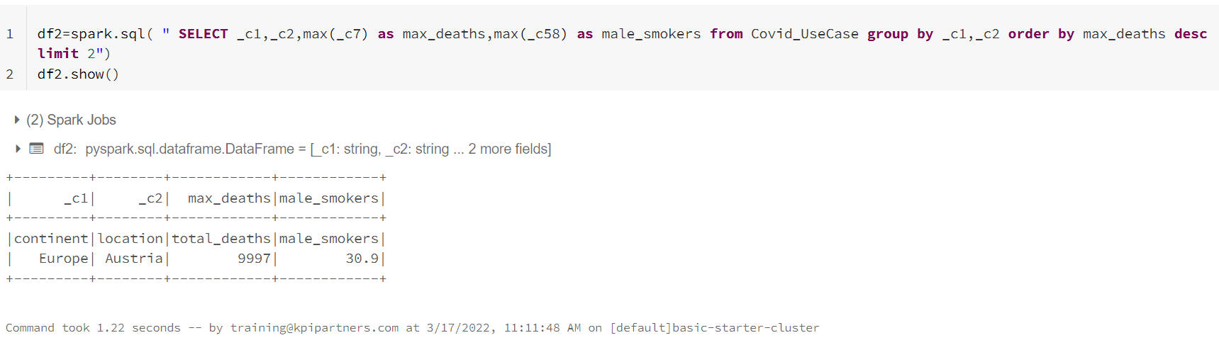

**5. Which year having the highest number of deaths**

